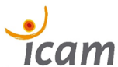

Toulouse Campus
Staff Training

Meaningful Learning and Intercultural Teaching: Communicating through different languages’


Contact:
Nora LEMOUZY
@ Nora.lemouzy@icam.fr
+33-6 71 46 46 98

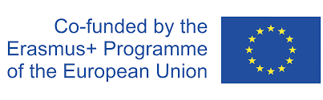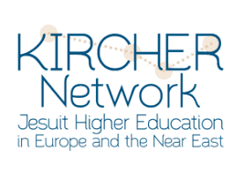

Staff Training – Icam, Toulouse Campus

Theme: Meaningful Learning and Intercultural Teaching: Communicating through different language environments’
📍 Icam Engineering School – Toulouse Campus
📅 June 3-5, 2026

The main objective of the staff training is to reflect upon meaningful learning from a language teaching perspective, as well as sharing best and innovative practices on intercultural dialogue within our institutions, in the classroom, in a tense geopolitical context.

-How do we communicate clearly, how do we debate when speaking the same language is not the only prerequisite to understanding each other?
-How do we guarantee a safe environment for everyone to take a stand, without marginalizing those with a different opinion, a different background?
-How do we safeguard a peaceful ground for a constructive debate, one whose objective is not to win the debate, but bring a positive outcome for the common good?

These are some of the questions that will be addressed by the participants (teachers, researchers and IR staff) who are facing these issues in their professional environments.

📅 Day 1 – June 3 (Monday)
Theme: Teaching with a purpose in a Multicultural Environment

09:30 – Opening Session
• Institutional Welcome
• Presentation of the Objectives & Participants

10:00 – Opening Keynote Conference
🎤 Guest Speaker: Magdalena (considered-Comillas)
Topic: Teaching with a purpose!

10:30 – Open Debate
Interactive discussion with participants on the keynote topic and shared experiences.

11:00 –Coffee Break

11:20—Best Practices (Call for Presentations)
Presentations by selected participants on projects related to Teaching with a Purpose in a Multicultural Environment.

1-Icam: French as a Professional Language: a Project with our Production School (public: school dropouts & migrants)

2-International Bachelor at Icam: when creating an inclusive classroom is a challenge! Students testimonials

13:00 – Lunch Break on campus

14:00 –Participants’ Project Presentations (Call for Presentations)
Continuation of presentations.

15:30 – Intercultural Workshop
🧱 Exploring Interculturality! A hands-on, creative session engaging participants with interculturality and the sense of belonging.

17:00 – End of Day 1 Activities
18:00—Cultural activity: Wine tasting downtown Toulouse
Free evening.

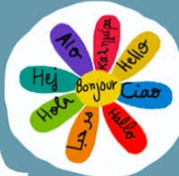

📅 Day 2 – June 4 (Tuesday)

Theme: Communicating through different language environment: signs at stake!

09:30 – Morning Conference
🎤 Speaker: Expert on Semiology
Topic: "Say what?!”: Is speaking the same language enough?

10:30 – Debating in a multicultural environment & tense geopolitical context
• Presentations educational projects: Estela (Loyola Cordoba)
•Critical thinking: Estela
• Presentations from other institutions (Call for Presentations)

13:00– Lunch Break on campus

14:30 – Ignatian Discernment activity: Xavier NUCCI, SJ (Icam)

15:45– Coffee Break
16:00—Language as a tool

• Cooperative classroom: Catherine MAURY Icam Toulouse and Quito + practice among participants

17:30 – End of Day 2 Activities

19:00--Dinner

📅 Day 3 – June 5 (Wednesday)

09:30 – Theme: Evaluation at stake: balancing academic and purpose-oriented objectives.

• Competence Based Approach by Icam (and others): the pros and cons
• Presentations from other participants (Call for Presentations)

11:00—Coffee Break

• Debate and new collective framework of evaluation
• Wrap-up session. Certificate of Attendance

13:00—Lunch on campus
🌐 End of Program



